TEKA KOMISJI URBANISTYKI I ARCHITEKTURY O/PAN W KRAKOWIE
URBANISTY AND ARCHITECTURE FILES
TOM XLIX / 2021 PL eISSN 2450-0038
s. XXX PL ISSN 0079-3450

FIRST AND LAST NAME
Academic/professional degree
Affiliation: official English name
e-mail:
ORCID:

PAPER TITLE IN POLISH ( not applicable for foreign authors)
PAPER TITLE IN ENGLISH

ABSTRACT
The abstract should be no longer than 500 characters with spaces. The abstract, in both Polish and English, should be a synthetic summary of the paper, informing readers of the subject matter under study, the study’s primary assumption, the research method it employed and its findings. Both elements, together with keywords, should fit on the title page. The main text of the paper should begin on the following page.
Keywords: 3–6 keywords

1. GENERAL INFORMATION
Correctly prepared manuscripts should consist of a Polish-language text and its full translation into English.

The first section should include the following subsections:
OBJECTIVE OF THE PAPER
METHODS
SCOPE
REVIEW OF THE LITERATURE
or a different equivalent text structure presenting an academic methodology suitable for the research findings presented.
The entire manuscript should not exceed 30,000 characters (15,000 PL + 15,000 ENG.).
(In justified cases it is acceptable to submit manuscripts that exceed this character count. This especially applies to archival materials. The publication decision is at the Editorial Team’s discretion).
The entire manuscript (with figures, the title page and references) should have an even number of pages.
Graphical elements such as figures, diagrams and photographs should be placed after the Polish version and in front of the English version of the text, with captions in both languages.

Please do not use:
-additional enters between paragraphs,
-hard spaces (non-breaking spaces, fixed spaces, no-breaks),
-page and section breaks—they have been predefined in this template,
-soft returns (forced line breaks).

2. REFERENCING FORMAT
Our journal uses Harvard referencing. Quoted text should be entered in italics (without quotation marks) and end in an in-text reference::
(Kowalski, 2018, s. 189) in the Polish text and (Kowalski, 2018, p. 189) in the English text.
- If there are two or three authors: (Kowalski, Nowak i Wiśniewski, 2018, s. 189). (Kowalski, Nowak and Wiśniewski, 2018, p. 189).
- If there are more than three authors: (Kowalski i in., 2017, s. 189) (Kowalski et al, 2017, p. 189)
- If there is no author listed: (Tytuł pracy, 2018, ss. 189–201) (Title, 2018, pp. 189–201).
- If there are references to works by the same author from the same year: (Kowalski, 2018a, s. 189) (Kowalski, 2018b, s. 56) (Kowalski, 2018a, p. 189) (Kowalski, 2018b, p. 56)
- If the citation refers to a work cited in a different source: (Kowalski, 2000, cytowany w Nowak, 2018, p. 189) (Kowalski, 2000, cited in Nowak, 2018, p. 189)
The same rules concern ideas cited from other works but are not direct quotes and are instead paraphrased. A detailed overview of referencing various forms of publications has been presented in the table below.
Online sources must be included in the references, with the website address, the name of the author of the text cited or the managing institution, and the date of access provided (see table 1 below).

Tab. 1.Referencing guidelines, by the Editorial Team

Book | Kowalski, K. (2018) Book title, 3rd edition. Kraków: Publisher name.
Book with multiple authors | Kowalski, K (ed.) (2015) Book title, Kraków: Publisher name
Chapter in a book with multiple authors | Kowalski, K. (2015) ‘Chapter title ’ in Nowak A. (ed.) Book title, Kraków: Publisher name pp. 340–350.
E-book, book available online | Kowalski, K., Nowak, A. (2018) Book title. E-book library [online]. Available at: https://www.pagename.pl, DOI, (Accessed: 07. January 2019)  (NOTE: a full URL address should be provided, without the link removed)
Article within a journal | Kowalski, K. ‘Article title’, Journal title, 53(8)2018, pp.70–81.
Article within an online journal | Kowalski, K. ‘Article title’, Journal title, 53(8)2018 [online] Available at: https://www.pagename.pl, DOI, (Accessed: 07. January 2019)  (NOTE: a full URL address should be provided, without the link removed)
Reference to a website | Kowalski, K. (2018) Title [Online]. Available at: https://www.pagename.pl (Accessed: 07. January 2019)  (NOTE: a full URL address should be provided, without the link removed)

The reference list is to be placed on a separate page, at the end of the manuscript. It is to be arranged in alphabetical order of author surnames, or, should a given item not have an author, the title. All references cited in the study or that served as a basis for it should be included in the list. The reference list should be numbered.

3. TEXT LAYOUT
It is recommended to use sections and subsections (appropriate styles have been included in this template under the ‘styles’ tab).
The manuscript should Begin with an introduction to the subject and clearly state the objective of the study, presenting it in the context of current research (the literature).

The paper should end with concrete conclusions and a summary.

Manuscripts that do not meet formatting guidelines shall not be accepted for review.

The entire manuscript (along with the title page, the Polish and English texts, figures, references and author biography) should have an EVEN NUMBER OF PAGES.

4.TEXT FORMATTING
The text in the manuscript should be formatting using SOLELY predefined styles that can be accessed via the Styles and Formatting window. They can also be accessed under Styles in the ribbon menu.
To correctly format the text, one should open this template in a separate window and open the manuscript file in a second window. Afterwards, please copy each part of the text into the corresponding places in the template. Then, each part is to be given its corresponding style from the styles palette (whose names begin with 1_TEKA…). They contain all the document formatting principles (fonts, paragraph settings, etc.).
Enabling predefined user styles in MS Word versions older than 2003 (.doc): in the top menu, please select: Format → Styles and Formatting. Enabling in MS Word versions later than 2003 (.docx): on the ribbon, select the Home tab and open the Styles window. The format can be changed most comfortably by placing the cursor on the paragraph and then pressing the corresponding button on the Styles and Fromatting dialogue.

Tab. 2 .XXXXXXXX By. XXXXXXXX

5.FIGURES
Graphical materials should be placed in predefined tables. The Editorial Team shall reserve the right to modify the placement of graphical material in the text for reasons associated with editing.
Below is a sample of how tables and images with a full-page width can be inserted into the manuscript. We allow monochromatic and colour figures. The graphical material should be of good quality (300 dpi for raster images and 600 dpi for vector images).

. 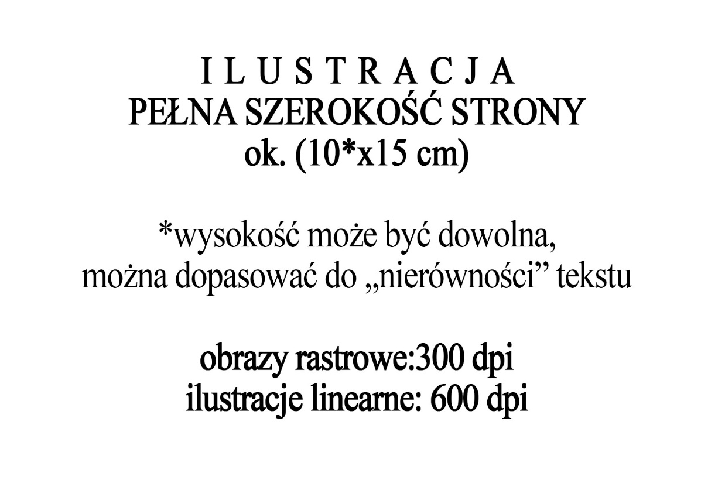
Il. 1. Placement of the figure on a single page. Source or author of the figure
Ill. 1. Caption in English
Il. 2. Placement of the figure on a single page. Source or author of the figure
Ill. 2. Caption in English

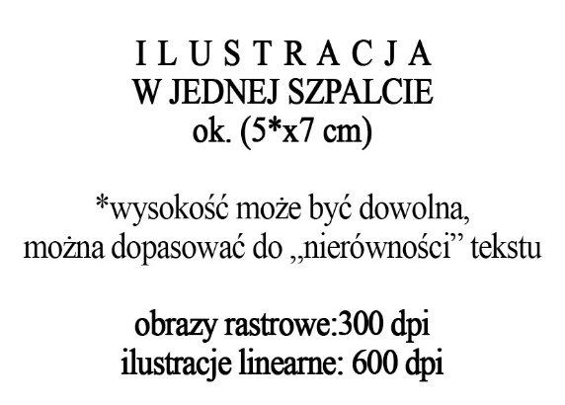
Il. 3. Placement of the figure on a single page. Source or author of the figure  Ill. 3. Caption in English | Il. 4. Placement of the figure on a single page. Source or author of the figure  Ill. 4. Caption in English

REFERENCES
- Kowalski, K. (2018) Book title, 3rd edition. Kraków: Publisher name,
- Kowalski, K. ‘Article title’, Journal title, 53(8)2018, pp.70–81,
- Nowak, A. (2018) Book title. E-book library [online]. Available at: https://www.nazwastrony.pl, DOI, (Accessed: 07. January 2019),

.

